SQL Analysis Report
HR Analytics: Employee Attrition Analysis

-- 1. Total Employees
SELECT COUNT(*) AS Total_Employees FROM hr_analytics; 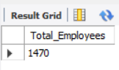
Results : 1470

-- 2. Total Attrition Count
SELECT COUNT(*) AS Attrition_Count FROM hr_analytics
WHERE Attrition = 'Yes';
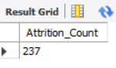
Results : 237

-- 3. Attrition Rate
SELECT ROUND((COUNT(CASE WHEN Attrition='Yes' THEN 1 END) * 100.0) / COUNT(*),2) AS Attrition_Rate FROM hr_analytics;
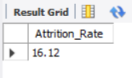
Results : 16.12

-- 4. Employee Count by Department
SELECT Department,
COUNT(*) AS Employee_Count
FROM hr_analytics
GROUP BY Department
ORDER BY Employee_Count DESC;
Results:
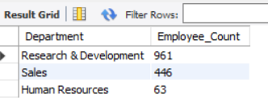
-- 5. Attrition by Department
SELECT Department,
COUNT(*) AS Attrition_Count
FROM hr_analytics
WHERE Attrition='Yes'
GROUP BY Department
ORDER BY Attrition_Count DESC;
Results:
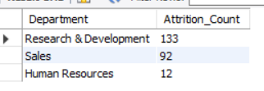

-- 6. Attrition by Job Role
SELECT JobRole,
COUNT(*) AS Attrition_Count
FROM hr_analytics
WHERE Attrition='Yes'
GROUP BY JobRole
ORDER BY Attrition_Count DESC;
Results:
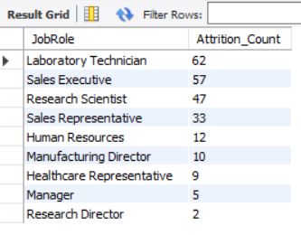

-- 7. Average Monthly Income by Department
SELECT Department,
ROUND(AVG(MonthlyIncome),2) AS Avg_Income
FROM hr_analytics
GROUP BY Department
ORDER BY Avg_Income DESC;

Results:
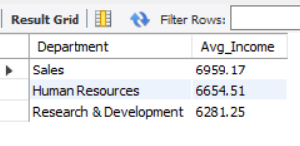

-- 8. Average Age by Department
SELECT Department,
ROUND(AVG(Age),2) AS Avg_Age
FROM hr_analytics
GROUP BY Department;
Results:
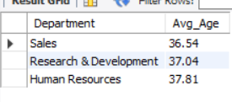

-- 9. Overtime Impact on Attrition
SELECT OverTime,
COUNT(*) AS Employees,
SUM(CASE WHEN Attrition='Yes' THEN 1 ELSE 0 END) AS Attrition_Count
FROM hr_analytics
GROUP BY OverTime;

Results:
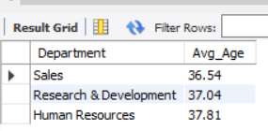

-- 10. Gender Distribution
SELECT Gender,
COUNT(*) AS Total_Employees
FROM hr_analytics
GROUP BY Gender;
Results:
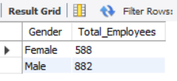

-- 11. Attrition by Gender
SELECT Gender,
COUNT(*) AS Attrition_Count
FROM hr_analytics
WHERE Attrition='Yes'
GROUP BY Gender;
Results:
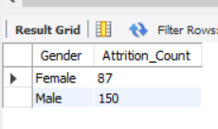

-- 12. Job Satisfaction Analysis
SELECT JobSatisfaction,
COUNT(*) AS Employees
FROM hr_analytics
GROUP BY JobSatisfaction
ORDER BY JobSatisfaction;

Results:
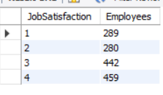
-- 13. Attrition by Job Satisfaction
SELECT JobSatisfaction,
COUNT(*) AS Attrition_Count
FROM hr_analytics
WHERE Attrition='Yes'
GROUP BY JobSatisfaction
ORDER BY JobSatisfaction;

Results:
